Steps:

-Created Edge Runtime Template in IoT Central and published it.

-Registered Edge Device in IoT Central.

-Added custom telemetry fields.

-Deployed Vm and installed Edge Runtime on it.

-Registered Edge Device on it via symmetric key provisioning.

-Applied the changes in the configuration file.

-Restart iotedge

-Listed Modules.

-Modules deployed successfully.

Pic 1)Modules running on Vm.

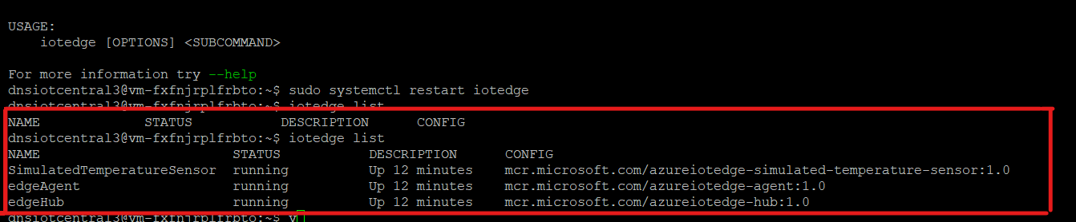

Pic 2) Device Status changed to Provisioned.

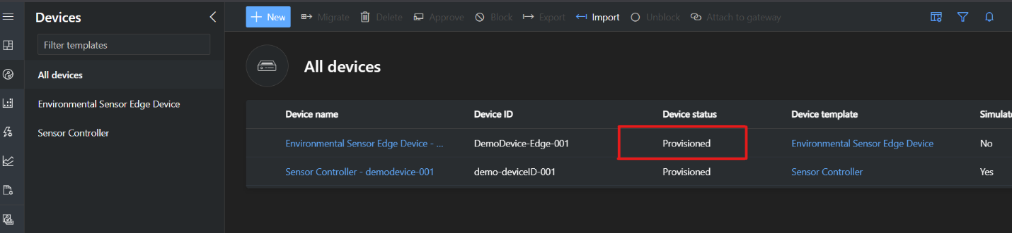

Pic 3)Modules and there Status listed on IoT Central.

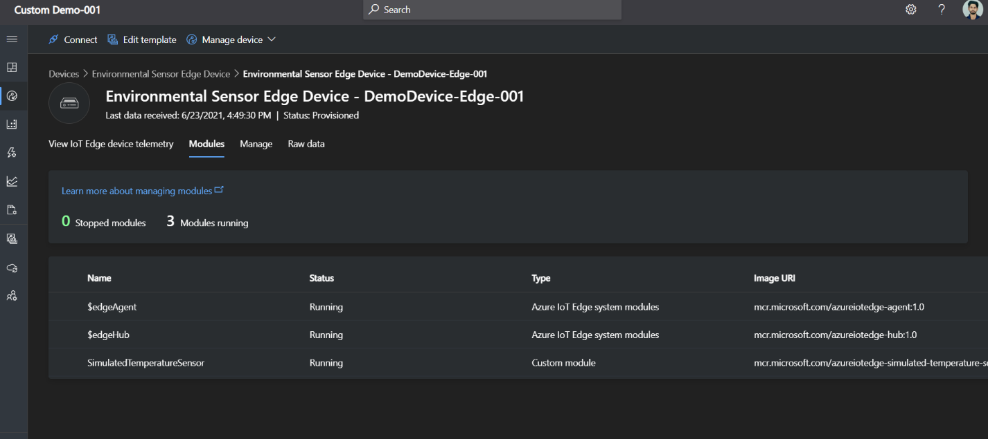

Pic 4) Telemetry Using Dashboard Function.

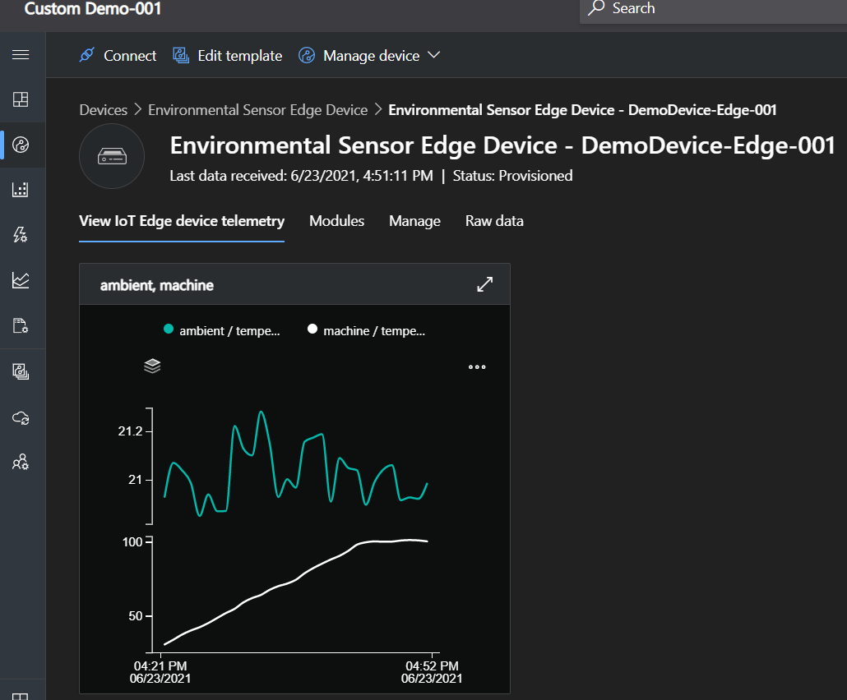

Pic 5)Telemetry Using Raw JSON file we manifested during building template of device.

